**DAILY ONLINE ACTIVITIES SUMMARY**

|  |  |  |  |  |  |  |  |  |
| --- | --- | --- | --- | --- | --- | --- | --- | --- |
| **Date:** | **18/06/2020** | | | | | **Name:** | **PRANEETA P HANDRAL** | |
| **Sem & Sec** | **4​th​ SEM. & ‘B’ SEC.** | | | | | **USN:** | **4AL19CS401** | |
| **Online Test Summary** | | | | | | | | |
| **Subject** | | **- -** | | | | | | |
| **Max. Marks** | | **30** | | **Score** | | | **- -** | |
| **Certification Course Summary** | | | | | | | | |
| **Course** | **Blockchain Essentials** | | | | | | | |
| **Certificate Provider** | | | **Cognitive class** | | **Duration** | | | **6 Hrs.** |
| **Coding Challenges** | | | | | | | | |
| **Problem Statement:** Write a C Program to generate first N Magic Numbers.  **Problem Statement:** Find the smallest positive integer value that cannot be represented as sum of any subset of a given array sorted in ascending order. | | | | | | | | |
| **Status:** **Executed.** | | | | | | | | |
| **Uploaded the report in Github** | | | | | **Yes** | | | |
| **If yes Repository name** | | | | | **LockdownCoding**  <https://github.com/praneetahandral/lockdowncoding> | | | |
| **Uploaded the report in slack** | | | | | **Yes** | | | |

**Online Test Summary:** No internals conducted.

**Online Certification course Summary​:** I have taken my Online Certification Course in **Cognitive class**  the course which I have opted is **Blockchain Essentials**. Course contains videos, tutorials, assessments and quiz. Today I have gone **IBM and Blockchain?** and An overview of **How IBM can help.**

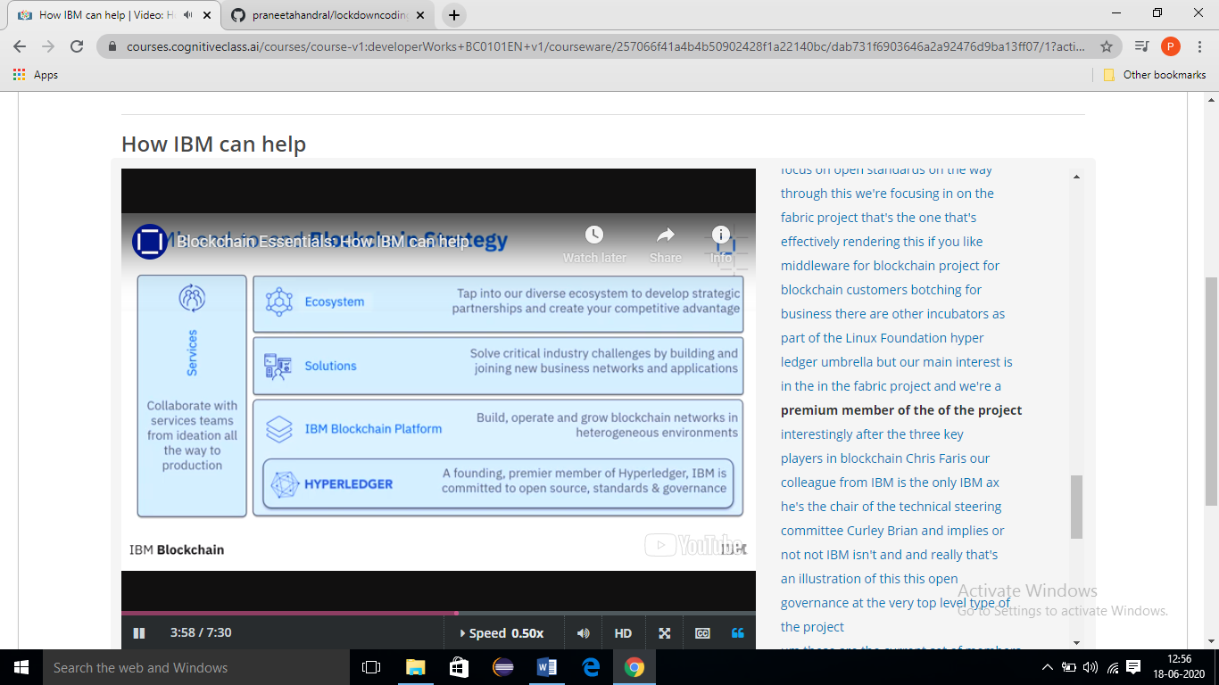

**Online Coding Summary​:** Today I received Two programs from prof. Venkatesh CSE Dept.. I have written one program and uploaded it to my Github repository. This is my repository snapshot. I have uploaded the frequency program.

